- What is the output of this program, if we run as “java Test 1 2 3”?
public class Test {
public static void main(String [] args)
{
String [][] argu = new String[2][2];
int x;
argu[0] = args;
x = argu[0].length;
for (int y = 0; y < x; y++)
System.out.print(" " + argu[0][y]);
}
}
Ans:______________________________

- What will be the output of following code snippet?
public class Test {
public static void main(String[] args) {
int arr[] = {1,2,3,4,6};
int i=2;
for(i=0; i<arr.length; ++i);
System.out.println(i);
}
}
Ans:______________________________

- ______________ qualifier declares a class variable that is to be shared among all instances.
Ans:______________________________

- What will be the output of following code snippet? Specify the reason.
public class Test {
int x=20;
public static void main(String[] args) {
System.out.println(++x);
}
}
Ans:__________________________________
_____________________________________
_____________________________________
- What will be the output of following code?
public class Test {
public static void main(String args[]) {
String s1 = “Hello”;
String s2 = new String(s1);
System.out.println(s1==s2);
}
}
Ans:__________________________________

6. -23 % 5 is _________________________.

- Math.pow(4, 1/2) returns ____________.

- What is y after the following switch statement is executed?
int x = 3, y = 4;
switch (x + 3) {
case 6: y = 0;
case 7: y = 1;
default: y += 1;
}
Ans:__________________________________

- Write the order of the precedence (from high to low) of the operators binary +, *, &&, ||, ^.
Ans:__________________________________

- What is the output of
System.out.println('z' - '9') ?
Ans:__________________________________

11. Suppose s1 and s2 are two strings. Which of the following statements is/are incorrect?
a. String s3 = s1 - s2;
b. boolean b = s1.compareTo(s2);
c. char c = s1[0];
d. char c = s1.charAt(s1.length());
Ans:__________________________________

- What is the return value of "GRAPHIC".substring(0, 5)?
Ans:__________________________________
13. What will be the output of following code snippet? Specify the reason?
int y = 0;
for (int i = 0; i < 10; ++i) {
y += i;
}
System.out.println(i);
Ans:__________________________________
_____________________________________
_____________________________________

14. What will be the output of following program?
public class Test {
public static void main(String[] args) {
double[] x = {2.5, 3, 4};
for (double value: x)
System.out.print(value + " ");
}
}
Ans:_________________________________

15. What is output of the following code?
public class Test {
public static void main(String[] args) {
int[] x = {120, 200, 016};
for (int i = 0; i < x.length; i++)
System.out.print(x[i] + " ");
}
}
Ans:_________________________________

16. What will be the output of following code?
public class Test {
public static void main(String[] args) {
int[][] x = { {1,2,3}, {4,5,6}, {7,8,9} };
for (int i = 0; i < 3; i++)
for (int j = 0; j < 3; j++)
x[i][j] = x[j][i];
for (int i = 0; i < 3; i++)
for (int j = 0; j < 3; j++)
System.out.print(x[i][j] + “ “);
}
}
Ans:_________________________________
17. What will be the output of following code?
public class Test {
public static void main(String[] args) {
int[] x = {1, 2, 3, 4};
int[] y = x;
x = new int[2];
for (int i = 0; i < y.length; i++)
System.out.print(y[i] + " ");
}
}
Ans:__________________________________

18. When you pass an array to a method, the method receives _______________________
_____________________________________.

19. The JVM stores the array in an area of memory, called ________________________, which is used for dynamic memory allocation where blocks of memory are allocated and freed in an arbitrary order.

20. How many public classes a .java file can have?
Ans:__________________________________

21. Assume double[][] x = new double[4][5]. The value of x.length and x[2].length will be ____________ and ___________ respectively.

22. Default constructor is not necessary to be defined, if parameterized constructor is defined and the object is to be created without arguments.
a. true
b. false
Ans:__________________________________
23. If a function can perform more than one type of tasks, where the function name remains same, this feature of OOP is called ____________________________________?

24. What is the output of this program?
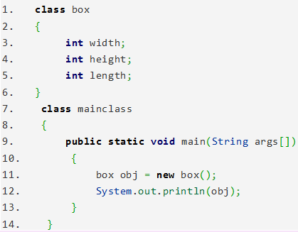
Ans:__________________________________
_______________________________________________________________________________________________________________

25. What is the output of this program?
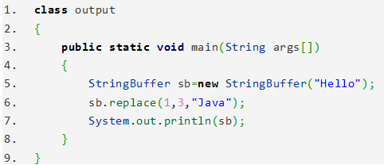

Ans:____________________________________________________________________________________________________________
26. What is the output of this program? Specify the reason.
package pack1;
class A
{
public A() {
//public constructor
}
}

package pack2;
import pack1.*;
class B {
A a = new A();
}
Ans:__________________________________
_____________________________________
_____________________________________
_____________________________________
_____________________________________

27. What is the output of this program?
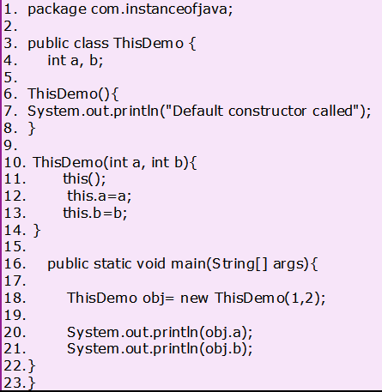
Ans:__________________________________
__________________________________________________________________________
28. What is the output of this program?
package main;
class T {
int t;
}

class Main {
public static void main(String args[]) {
T t1 = new T();
System.out.println(t1.t);
}
}
Ans:__________________________________
_____________________________________
_____________________________________
_____________________________________

29. What is the output of this program?
class Point {
int m_x, m_y;
public Point(int x, int y) {
m_x = x;
m_y = y;
}
public static void main(String args[])
{
Point p = new Point();
}
}
Ans:__________________________________
_____________________________________
_____________________________________
_____________________________________

30. What is the output of this program?
class Test1 {
static int x = 10;
public
static void main(String[] args)
{
Test1 t1 = new Test1();
Test1 t2 = new Test1();

t1.x = 20;
System.out.print(t1.x + " ");
System.out.println(t2.x);
}
}
Ans:__________________________________
_____________________________________
_____________________________________
_____________________________________

Key
- 1 2 3
- 5
- static
- Error (Non-static variable x cannot be referenced from a static context)
- false
- -3
- 1.0
- 2
- *, +, ^, &&, ||
- 65
- All of them
- GRAPH
- Error (i is not defined after the loop.)
- 2.5 3.0 4.0
- 120 200 14 (016 is an octal number.)
- 1 2 3 4 5 6 7 8 9
- 1 2 3 4
- the reference of the array
- heap
- Only one (A .java file can have maximum one public class.)
- 4, 5
- False
- Polymorphism
- classname@hashcode in hexadecimal form
- HJavalo
- Compile time error (Because, Class-A itself has been defined with default access modifier. That means Class-A can be instantiated within the package in which it is defined. It can not be instantiated outside the package, even though it has public constructor.)
- Default constructor called
1
2
- 0
- Error (Actual and formal argument list of Point constructor is different. Default constructor is needed.)
- 20 20

